**Galaxy tools and settings for Variant calling using BCFtools:**

1. Upload reference files (FungiDB-65_AfumigatusAf293_Genome.fasta, FungiDB-65_AfumigatusAf293_Genome.gff ) and Nacl sequence files (Af_NaCl_0_1_EKDN230045909-1A_HVJG7DSX7_L4_1.fq.gz , Af_NaCl_0_1_EKDN230045909-1A_HVJG7DSX7_L4_2.fq.gz ) in galaxy
2. Select tool “**Cutadapt**”

* Select Paired end
* Select both reads 1 and 2 of sample
* Select “Enter Custom sequence” in Adapter sequence to be trimmed. Enter following as adapter sequences for 3 and 5 end:

5' Adapter:

  5'-AGATCGGAAGAGCGTCGTGTAGGGAAAGAGTGTAGATCTCGGTGGTCGCCGTATCATT-3'

  3' Adapter:

  5'-GATCGGAAGAGCACACGTCTGAACTCCAGTCACGGATGACTATCTCGTATGCCGTCTTCTGCTTG-3'

* In “Filter Options”, select “Minimum length” to 20 for both read 1 and 2.
* In “Read Modification Options”, “Quality cutoff” to 20
* In “Output Selector”, “Report”  as Yes
* Keep other as default settings and click “Execute”.

<https://help.galaxyproject.org/t/cutadapt-galaxy-tutorial-inserting-adaptor-sequence/6389>

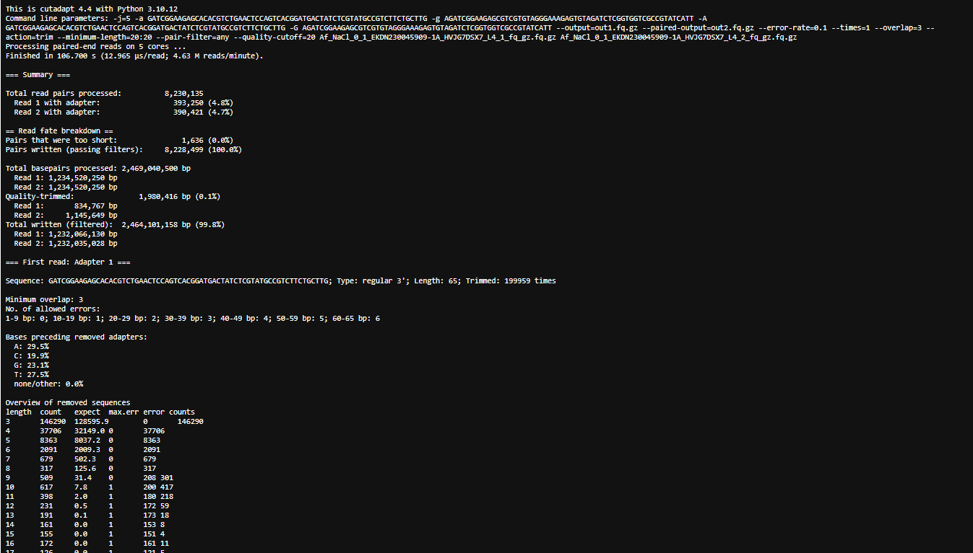

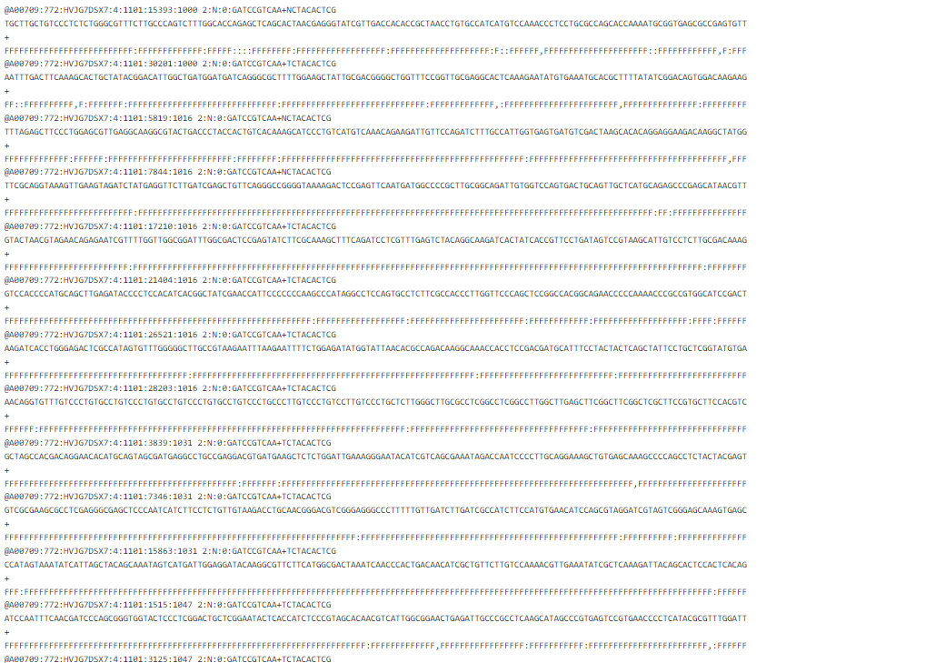

1. Select tool “**Fastqc**”

* In “ Raw read data from your current history”, select original fasta files of paired end reads and files generated from cutadapt.
* Keep other as default settings and click “Execute”.

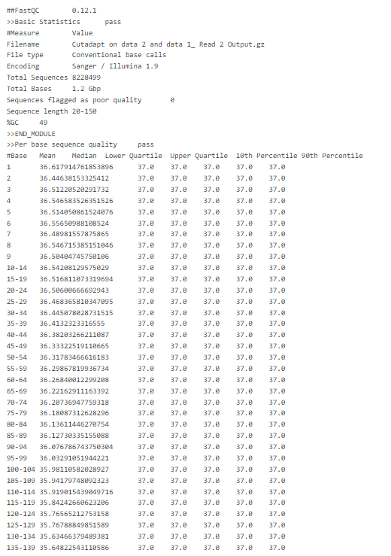

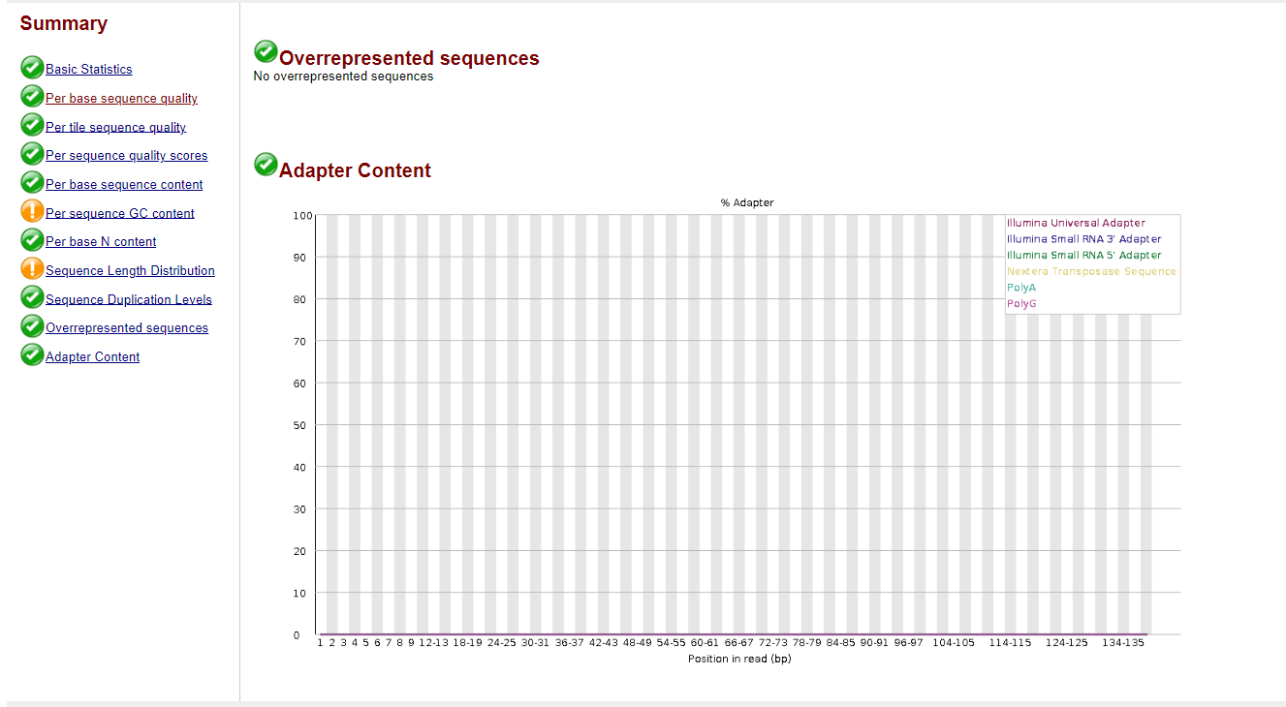

1. Select tool “**BWA-MEM2**”, for alignment and sorting.

* Select “Use a reference genome from the history and built index”, select file “FungiDB-65_AfumigatusAf293_Genome.fasta” as reference.
* Select “Paired end” reads, and choose the output files of Cutadapt.
* Keep “Analysis mode” to simple Illumina mode.
* Keep other as default settings and click “Execute”.

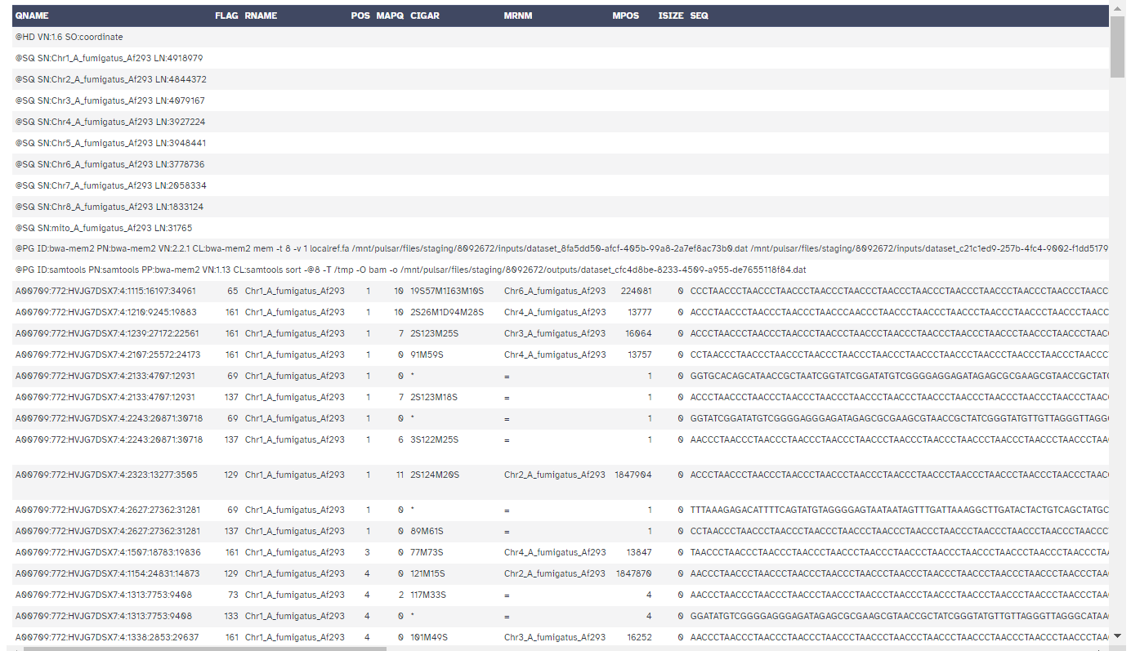

1. For summary statistics of alignment, select tool “**Samtools flagstat**”

* Select BWA-MEM2 alignment bam file.
* Keep other as default settings and click “Execute”.

<https://youtu.be/V6Lf9p7KrRc?feature=shared>

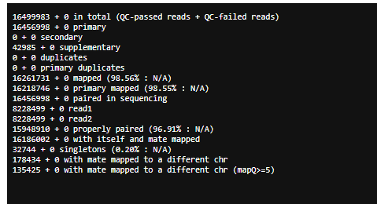

1. Select tool “**Bcftools mpileup**”.

* Choose the bam file generated from alignment
* Choose reference file “FungiDB-65_AfumigatusAf293_Genome.fasta” from history.
* Keep other as default settings and click “Execute”.

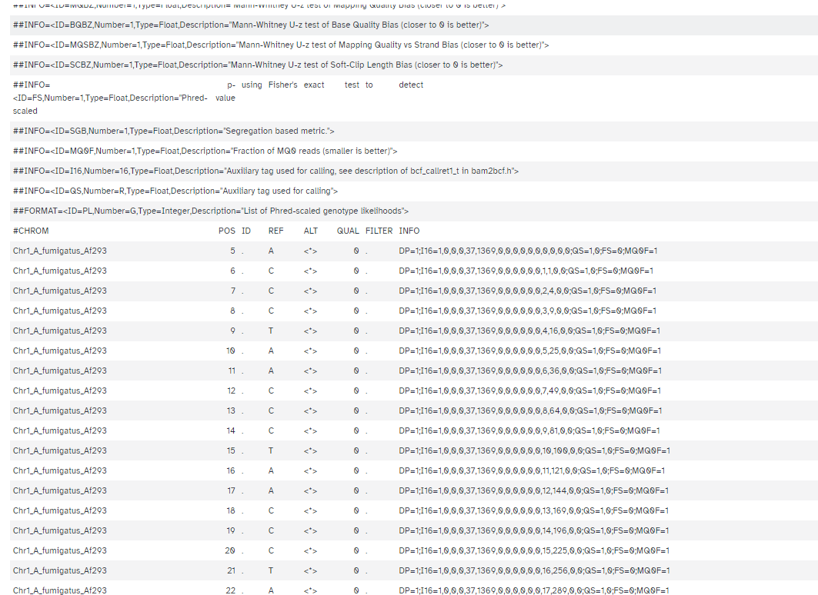

1. Select tool “**Bcf call**”, for variant calling.

* Select bcftools mpileup output file.

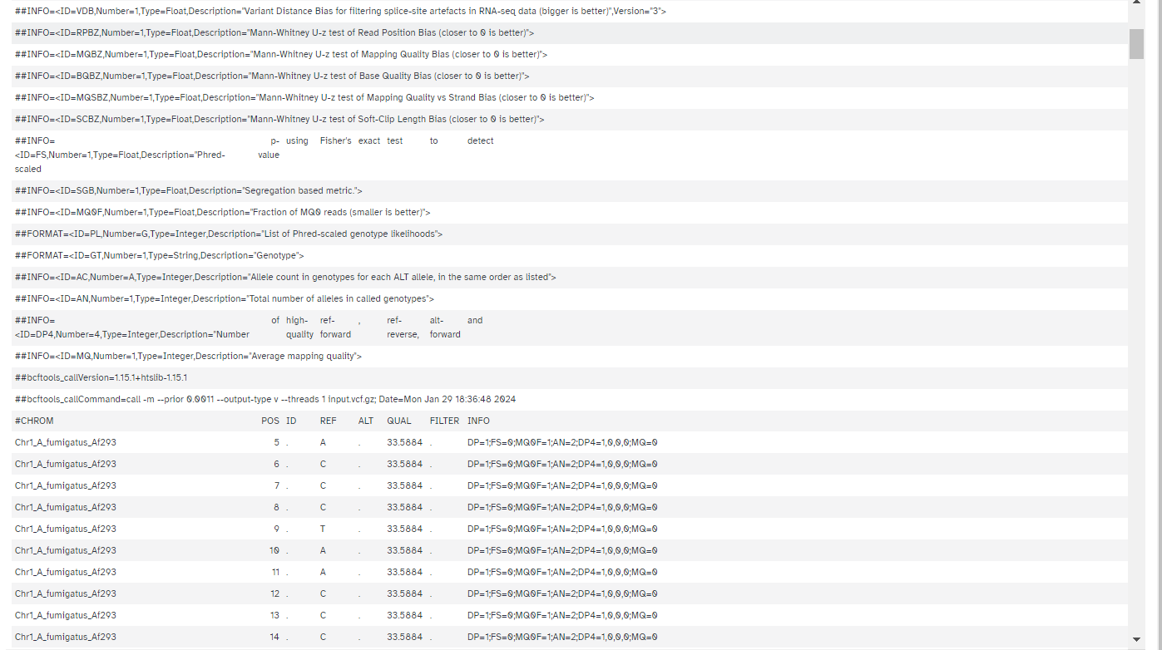

* Keep other as default settings and click “Execute”.

1. Select tool “**Bcftools count**”.

* Select BCF call file, keep other as default settings and click “Execute”.

<https://youtu.be/R8tqDTlkXOo?feature=shared>

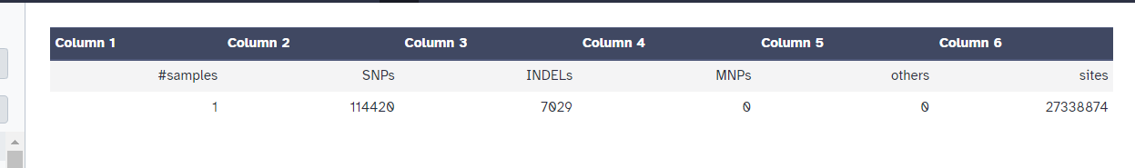

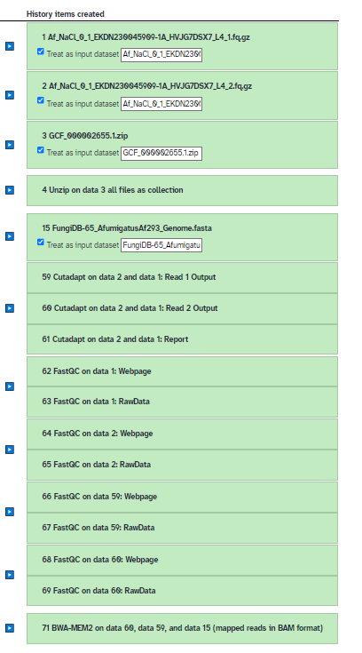

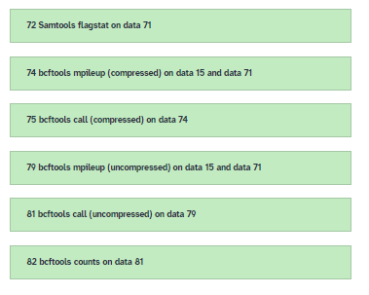

**Galaxy tools and settings for Variant calling using Snippy tool:**

Initial steps of **cutadapt** and **fastqc** are the same as followed in above pipeline.

1. Select “**Snippy tool**”

* Select “Use a genome from history and built index” and select ““FungiDB-65_AfumigatusAf293_Genome.fasta” as reference.
* Select “Paired end” reads and choose the output files of cutadapt
* In “Output selection”, check all outputs.
* Click “Execute”

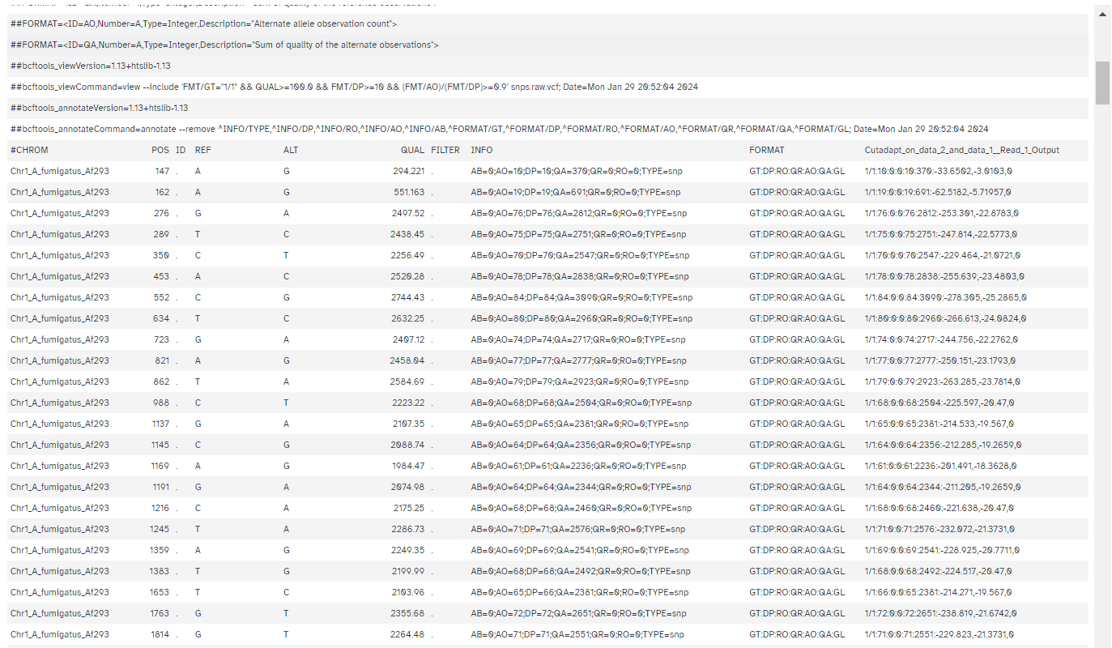

Vcf file

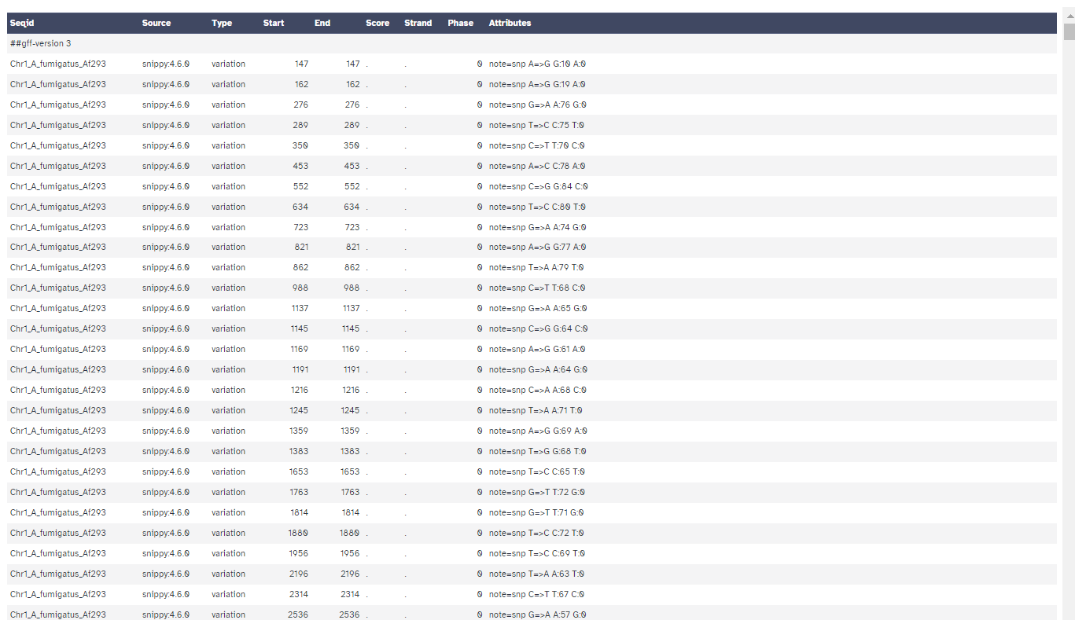

Gff file

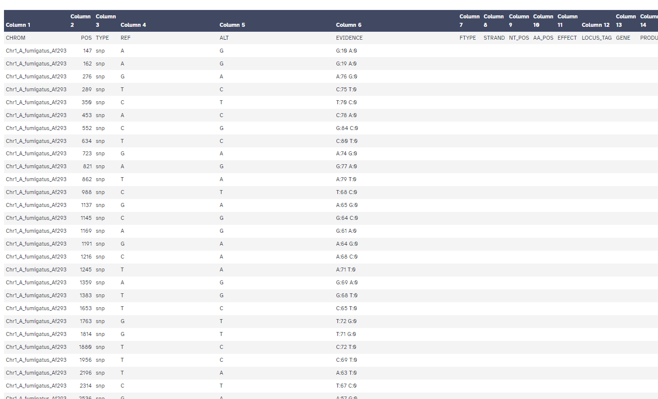

Snps table

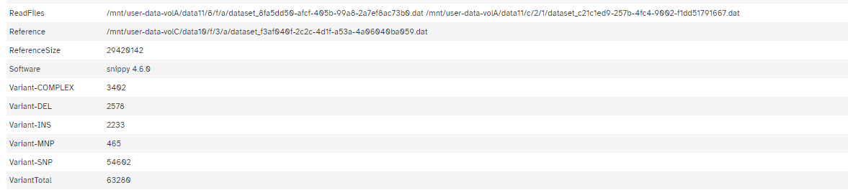

Snps summary

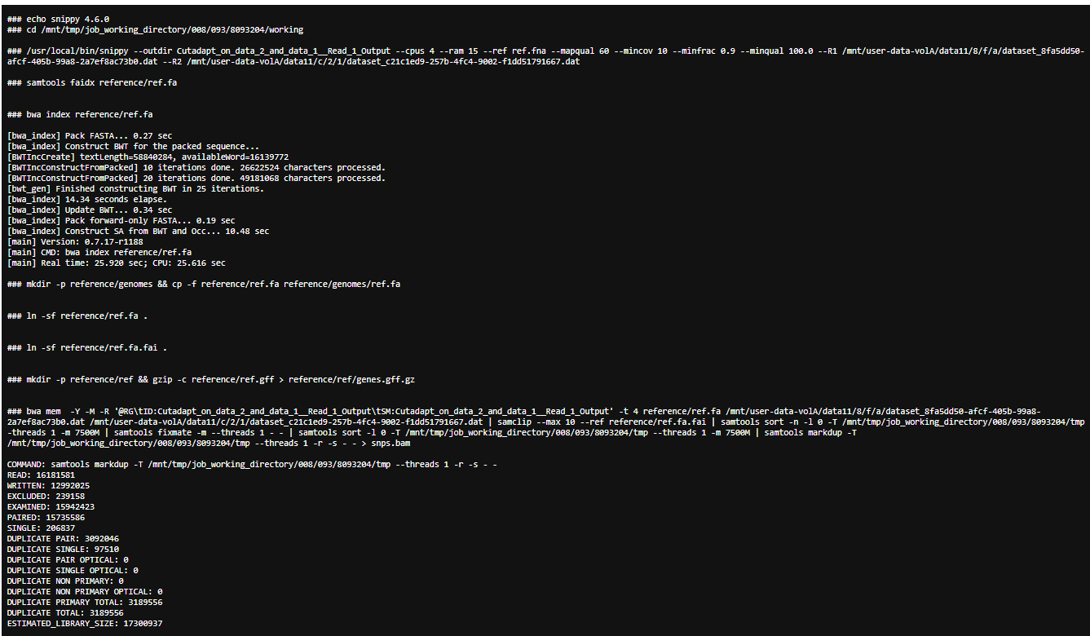

Log file



Aligned fasta file

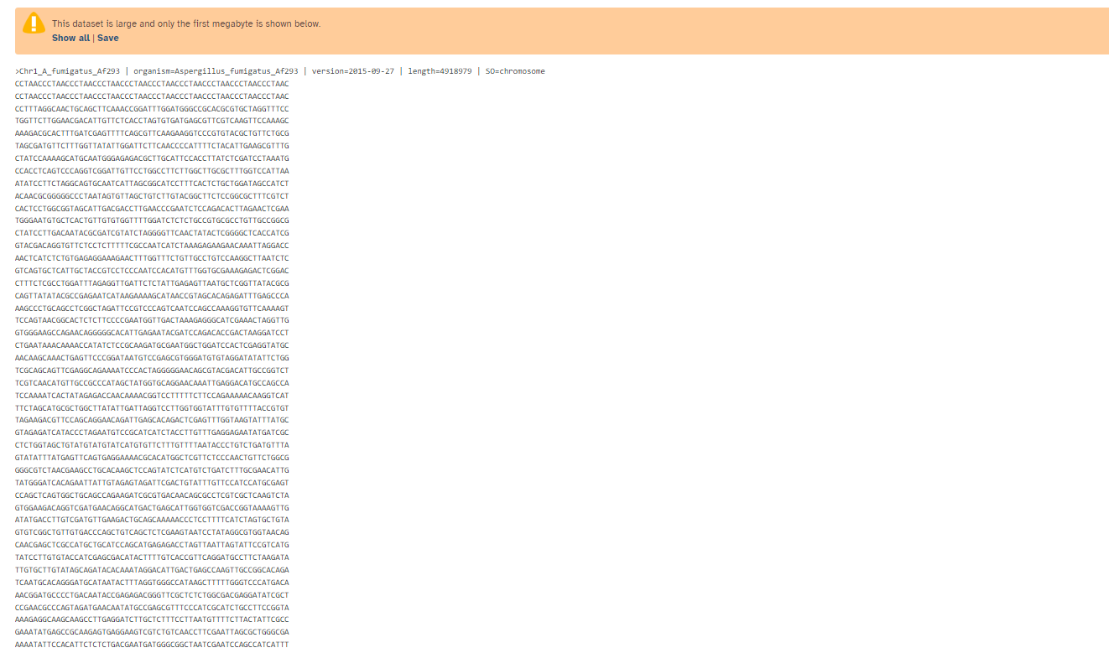

Consensus fasta file

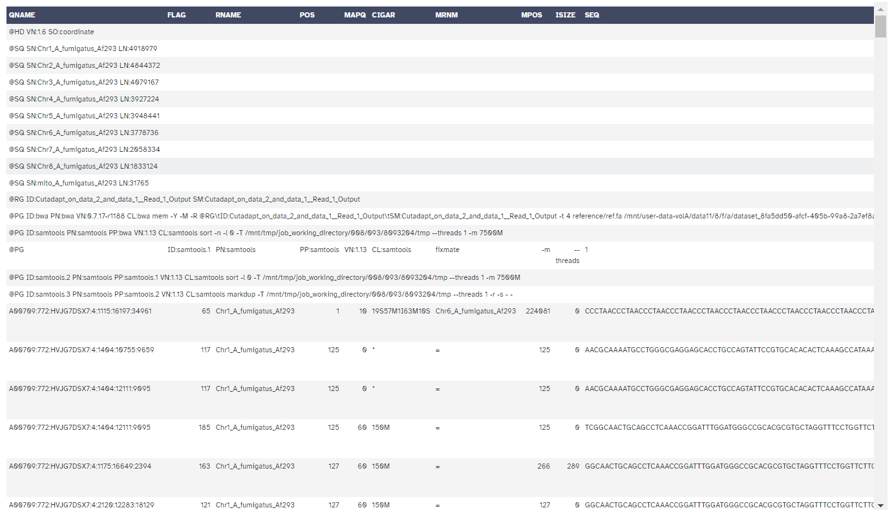

Mapped reads (bam file)

1. Select “**JBrowse**”

* Select “Use a genome from history and built index” and select ““FungiDB-65_AfumigatusAf293_Genome.fasta” as reference.
* Choose Track 1 Group and give it a name as “sequence reads”
* Choose annotation track and select bam pileups and the bam file generated from snippy tool.
* Select “Autogenerate SNP track” to yes.
* For track visibility, choose on for new users.
* Click “insert track”
* Name this track as variants
* Choose GFF file generated from snippy tool.
* For track visibility, choose on for new users.
* Click “insert track”
* Name this track as annotated reference
* Select “FungiDB-65_AfumigatusAf293_Genome.gff” file.
* For track visibility, choose on for new users.
* Click “Run tool”

<https://youtu.be/FB8D3UayLSc?feature=shared>



